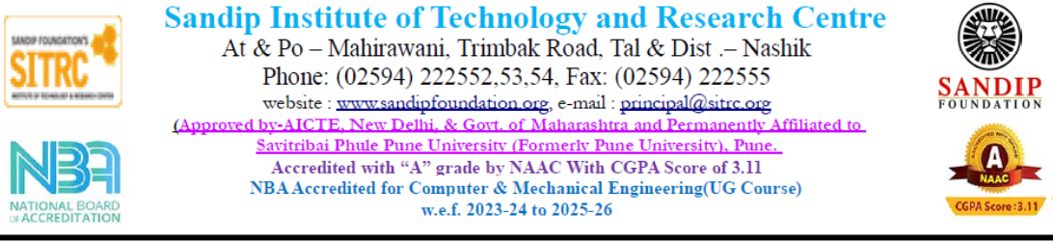

Event Report

Academic Year 2025-26 (Sem-II)

Name of the Event: National-level event Tech-SITRC

Sub-event: 1) Project competition 2) Chess Competition

Event Date: 18/04/2026

Event Conduction Duration: 10.00 am to 5.00 pm

Event Venue: Measurement lab , Electrical Engg Dept, E Building, SITRC

No of Participants: More than 100 from other institute

Name of Event Coordinator: Prof. R.B.Sadaphale (Asst. Prof SITRC, Electrical Dept)

The Department of Electrical Engineering successfully organized a national-level event, Tech-SITRC 2026, on 18th April 2026. The event aimed to provide a platform for students to showcase their technical expertise, innovative ideas, and strategic thinking skills.
The event consisted of two major sub-events: a Project Competition and a Chess Competition. The Project Competition encouraged participants to present innovative and practical engineering solutions, reflecting their creativity and technical knowledge. The Chess Competition, on the other hand, tested participants' analytical thinking, concentration, and strategic planning abilities.
The event witnessed enthusiastic participation from more than 100 students representing various institutions and organizations across the country, making it a truly national-level gathering. The diversity of participants contributed to a competitive and intellectually stimulating environment.
The event was coordinated by Prof. R. B. Sadaphale, whose dedicated efforts ensured smooth planning and execution. The guidance and support of the Head of Department, Dr. N. S. Patil, played a crucial role in the success of the event.
Overall, Tech-SITRC 2026 was a grand success. It not only provided a platform for knowledge exchange and skill development but also fostered healthy competition and collaboration among students from different backgrounds.
The Department of Electrical Engineering expresses sincere gratitude to all participants, organizers, and contributors for making this event memorable and impactful.
Objectives:
- To provide a national-level platform for students to showcase their technical knowledge and innovative project ideas.
- To encourage creativity, research, and practical implementation skills among engineering students.
- To promote healthy competition and enhance problem-solving abilities.
- To develop strategic thinking, concentration, and decision-making skills through activities like chess.
- To facilitate interaction and knowledge exchange among students from different institutions and backgrounds.
- To motivate students towards continuous learning and technological advancement.
- To identify and appreciate talented students in both technical and analytical domains.
Outcome:
- The event successfully enhanced students’ technical knowledge and practical skills through innovative project presentations.
- Participants demonstrated improved problem-solving abilities and creative thinking.
- The Chess Competition helped in developing strategic thinking, patience, and decision-making skills among students.
- Students gained exposure to diverse ideas and technologies by interacting with participants from different institutions.
- The event fostered healthy competition and boosted confidence among participants.
- It provided a valuable platform for networking, collaboration, and knowledge sharing at a national level.
- Talented students were identified and appreciated, encouraging them for future innovations and competitions.
- Overall, the event contributed to the academic and personal development of the participants.

Event Photo :
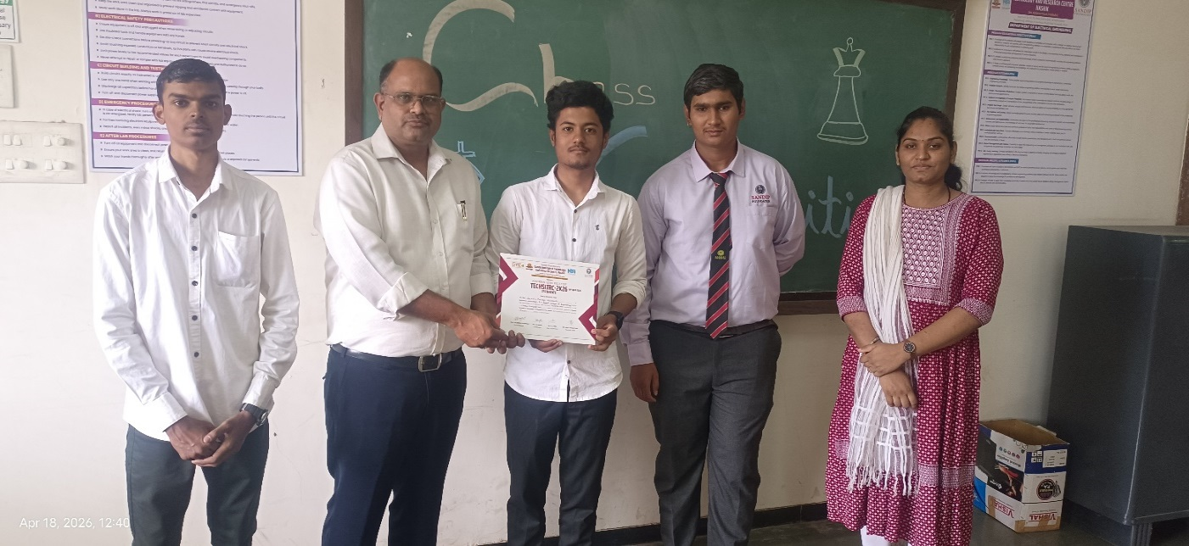

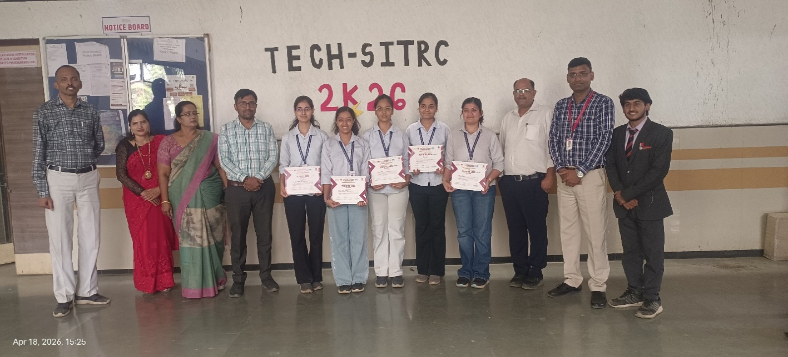

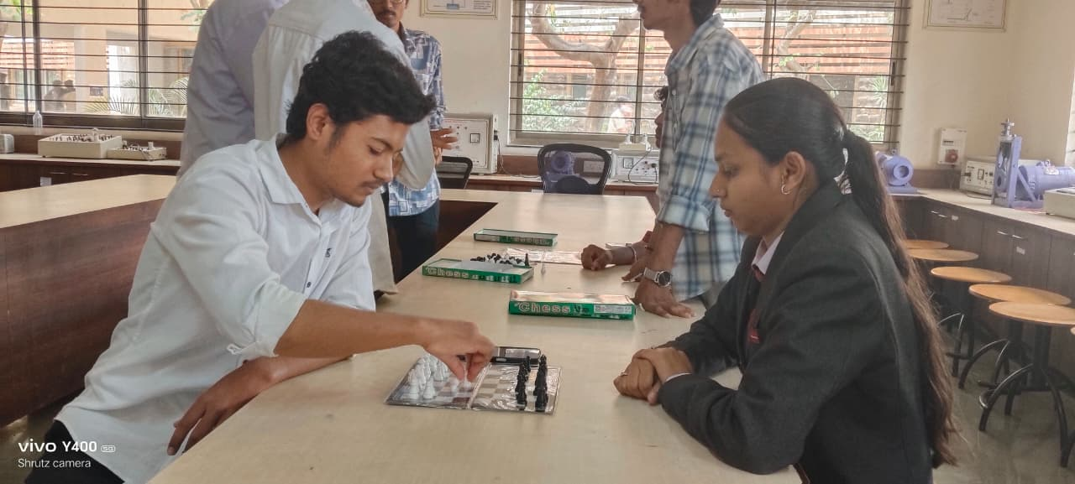

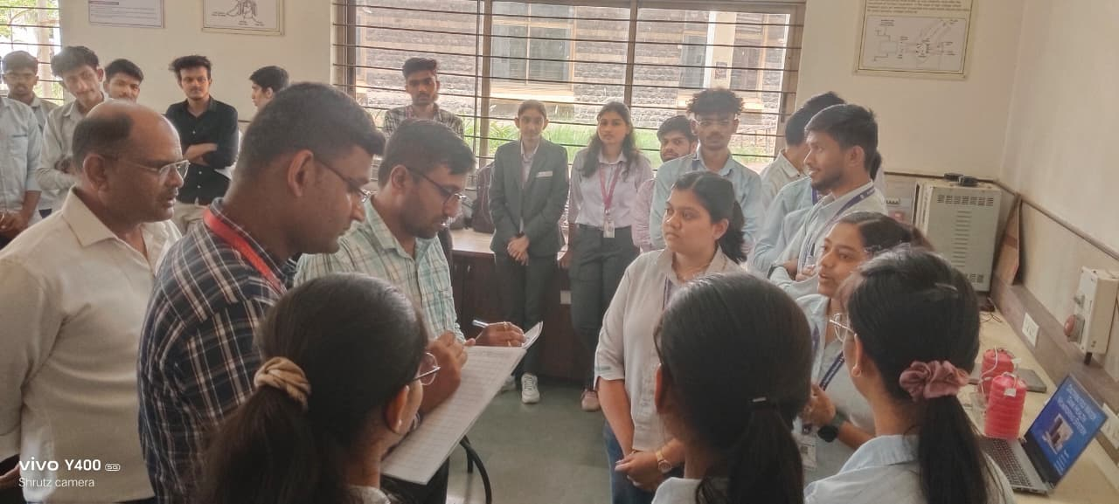

Event Coordinator | HOD Electrical | Principal

