Activity Report
on
Expert Talk on “Importance of Database Management Systems with Oracle, PL/SQL for Industry”

Name of Event: Expert Talk on “Importance of Database Management Systems with
Oracle, PL/SQL for Industry”
Date of Event: 28th January 2026
Type of the Event: Expert Talk
Name of Event Coordinator: Prof. Sangita Chaudhari, Assistant Professor, Dept. of AIML, SITRC, Nashik
Name of Resource Person: Mr. Kishor D. Chaudhari (Sr. Software Solution Architect in MAJESCO Software).
Venue-C-Building SITRC Second Floor (CS01) Nashik.
Audience: Students of S. Y. & T.Y. B. Tech students.
Total Students attended Program: 55
Objective:
The core industrial objectives is Creating high performance, secure, and automated data driven application with:
- Network Performance Optimization: PL/SQL allows developers to group multiple SQL statements into a single block. This significantly reduces network traffic between the application and the database server by replacing multiple round-trips with a single call.
- Centralized Business Logic (SmartDB): Industries use PL/SQL to encapsulate complex business rules directly within the database via stored procedures, functions, and packages. This ensures that all applications (web, mobile, or legacy) follow the same logic consistently.
- Enhanced Data Security: By exposing data only through PL/SQL interfaces, organizations can prevent SQL injection and unauthorized access. Users can be granted permission to execute a specific procedure without having direct access to the underlying tables.
- Transaction Reliability and Error Management: A primary objective is to maintain data integrity using PL/SQL’s robust exception handling. It allows programs to catch runtime errors (e.g., "insufficient funds") and respond gracefully without crashing the application.
- Process Automation: Using database triggers, industries automate routine tasks such as auditing changes, generating derived column values, or enforcing complex referential integrity rules that standard SQL cannot handle alone.
- Scalability and Manageability: Stored program units are compiled once and cached in shared memory, allowing the Oracle engine to support thousands of concurrent users efficiently. It also simplifies maintenance since a logic change only needs to be updated in one place—the database server—rather than on every client machine.
- Cross-Platform Portability: PL/SQL code is fully portable across any operating system or hardware that supports the Oracle Database, allowing companies to migrate infrastructure without rewriting application logic.
Highlights from the event:
The program commenced with an inaugural session led by the coordinator, where Dr. Dipak Bage, Head of Department, welcomed the resource person and participants. The expert speaker, Mr. Kishor D. Chaudhari (Sr. Software Solution Architect in MAJESCO Software), delivered an introductory talk on Creating high performance, secure, and automated data driven application using DBMS with Oracle and PL/SQL
Outcomes:
- Its Primary Outcomes center on transforming raw data into high-performance, secure and automated business assets.
- Participants gained a clear understanding to Oracle DBMS with PL/SQL serves as a cornerstone for enterprise-level data management.
- Students also gained a knowledge of how Oracle DBMS ,PL/SQL is used High-Performance Transaction Processing: Enhanced Data Security, Industry-Specific Applications such as banking, E-commerce and healthcare

Glimpse from the Event: -

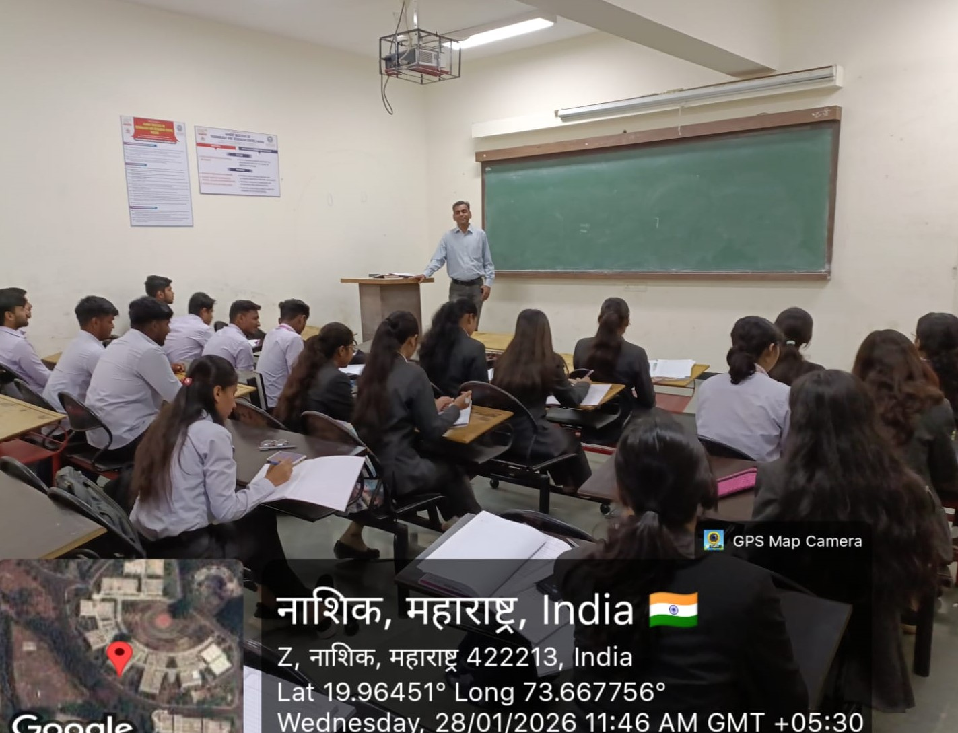

Photo: Students Attending Session

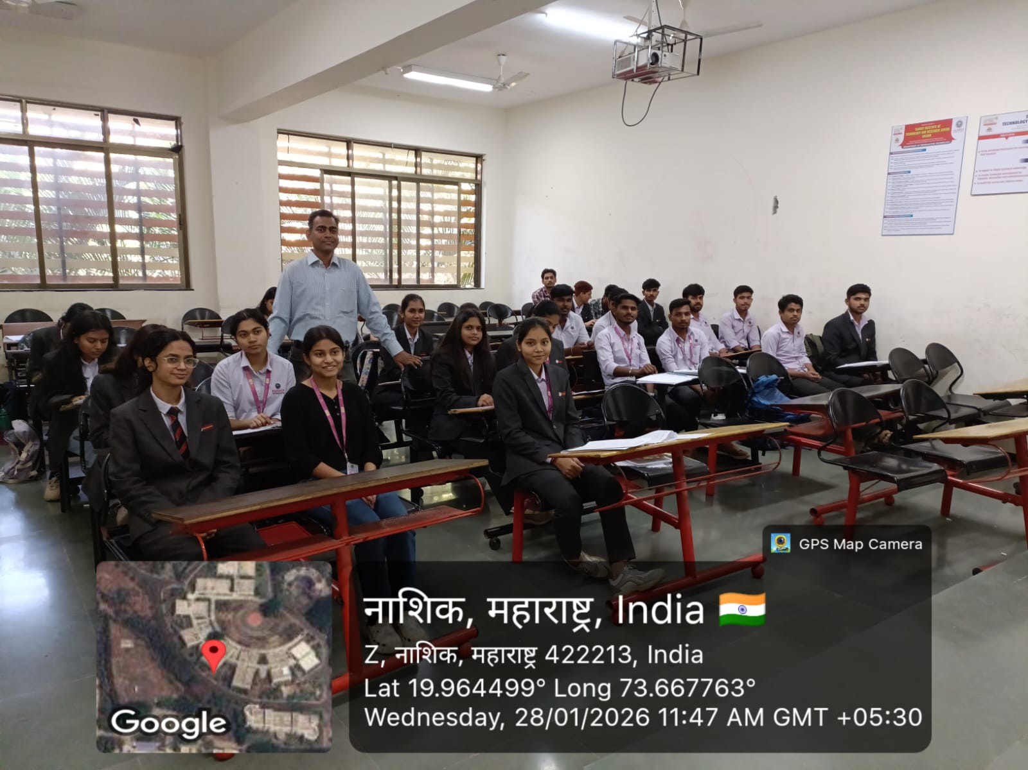

Photo: Group photo in Session


Prof. Sangita Chaudhari Dr. Dipak D. Bage
Event Co-ordinator AIML Department

